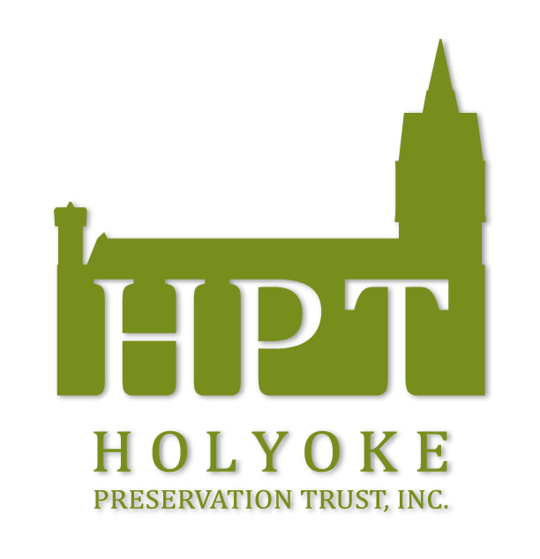
Holyoke Preservation Trust, Inc.

92 Race Street, Holyoke, MA 01040 * 413-437-0466 * info@holyokepreservationtrust.org

DROP OFF FORM #2 FOR SUBMISSIONS
In addition to the entry form (see brochure for age level forms), please complete this form and follow the directions for the submission of your work.

Drop off submission at Judd’s Restaurant at Gateway City Arts, 92 Race Street with
- Completed Entry Form (brochure)
- Complete ALL 3 sections below.
- Artist Copy of the submission to be used for pick-up (below)
- Complete and attach Part 3 to the back of the submission for identification and information. (below)
PLEASE PRINT CLEARLY
------------------------------------------------------------------------------------------------------------------
HPT File Copy

Artist: ______________________________________________________________
Title: ______________________________________________________________
Medium: __________________________________________________________
Price (adult submissions only): _________________________________
Phone:_____________________________________ Email: _______________________________________________
Signature: _________________________________________________________________________
------------------------------------------------------------------------------------------------------------------
Attach to the back of the Submission

Artist: ______________________________________________________________
Title: ______________________________________________________________
Medium: __________________________________________________________
Price (adult submissions only): _________________________________ Sold____ Not Sold____
Phone:_____________________________________ Email: _______________________________________________
Signature: _________________________________________________________________________
------------------------------------------------------------------------------------------------------------------
Artist Copy
Award Ceremony: June 5, 2022 at NOON at Gateway City Arts * Pick-up: June 5, 2022 3p.m.-5p.m.

Artist: ______________________________________________________________
Title: ______________________________________________________________
Medium: __________________________________________________________
Price (adult submissions only): _________________________________

